- Loopback addresses 127.0.0.0/8 ping 127.0.0.1 command to verify that Transmission Control Protocol/Internet Protocol (TCP/IP) is operating correctly on your computer or router.
- Private IP addresses – 10.0.0.0/8, 172.16.0.0/12, and 192.168.0.0/16
- (Link Local) Automatic Private IP Addresses (APIPA) – 169.254.0.0/16 addresses are link-local private addresses 169.254.0.0 through 169.254.255.255 address range; however, the first 256 and last 256 addresses from this range are reserved and must not be assigned to hosts.
- Multicast addresses – 224.0.0.0/4
- Global broadcast address – 255.255.255.255 is used to send data to every computer on a network or subnetwork.
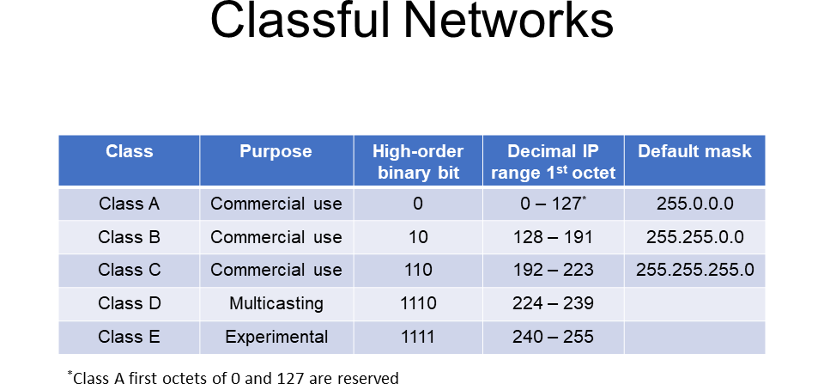
The following are the valid IP addresses in each of the classes available for commercial use as defined by RFC 1918:
Class A – 10.0.0.0 through 10.255.255.255
Class B – 172.16.0.0 through 172.31.255.255
Class C – 192.168.0.0 through 192.168.255.255

